DISHES AND THEIR ALLERGEN CONTENT – Cheese and meat platter

DISHES | 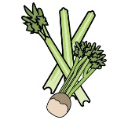 | 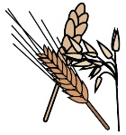 | 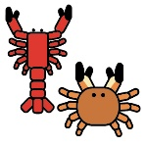
 | Celery | Cereals containing gluten | Crustaceans | Eggs | Fish | Lupin | Milk | Mollusc | Mustard | Nuts | Peanuts | Sesame seeds | Soya | Sulphur Dioxide
continental meats | Y | Y |  |  |  |  | Y |  | Y |  |  |  |  | Y
pork pie |  | Y |  | Y |  |  | Y |  | Y |  |  |  | Y | Y
homemade pate |  |  |  |  |  |  | Y |  |  |  |  |  |  | Y
chutney |  |  |  |  |  |  |  |  |  |  |  |  |  | Y
selection of breads |  | Y |  |  |  |  | Y
celery | Y
grapes
olives |  |  |  |  |  |  |  |  |  |  |  |  |  | Y
pickles |  |  |  |  |  |  |  |  |  |  |  |  |  | Y

Review date: | 30 September 2021 | Reviewed by: | Robert Stratton, Executive chef |  | You can find this template, including more information at www.food.gov.uk/allergy

