DISHES AND THEIR ALLERGEN CONTENT – COLD BUFFETS

DISHES | 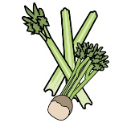 | 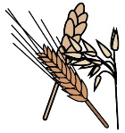 | 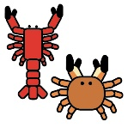 | 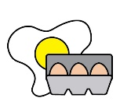 |  | 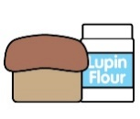 |  |  |  | 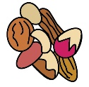 | 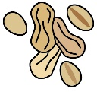 | 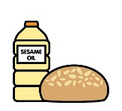
 | Celery | Cereals containing gluten | Crustaceans | Eggs | Fish | Lupin | Milk | Mollusc | Mustard | Nuts | Peanuts | Sesame seeds | Soya | Sulphur Dioxide
Honey and grain mustard-roasted ham |  |  |  |  |  |  |  |  | Y
Smoked duck breast with watercress and beetroot |  |  |  |  |  |  |  |  |  |  |  |  |  | Y
Smoked salmon and prawn platter |  |  | Y |  | Y
Broccoli and Yorkshire blue cheese tartlets |  | Y |  | Y |  |  | Y |  |  |  |  |  |  | Y
Minted pea and red pepper frittata |  |  |  | Y |  |  | Y |  |  |  |  |  |  | Y
Vine tomato, olive and pesto salad |  | Y |  |  |  |  | Y |  |  | Y
Potato salad with spring onions and chives |  |  |  |  |  |  | Y
Mixed green salad
Buttered new potatoes |  |  |  |  |  |  | Y
Freshly baked bread |  | Y
Platter of continental meats including chorizo, pastrami, Parma ham  and bresaola | Y | Y |  |  |  |  | Y |  |  |  |  |  | Y | Y
Teriyaki-marinated salmon fillets | Y |  | Y |  | Y |  |  | Y |  |  |  | Y | Y | Y
Mediterranean vegetable terrine
Broccoli and Stilton tartlets |  | Y |  | Y |  |  | Y |  | YY |  |  |  |  | Y
Cajun spiced rice salad | Y
Marinated olives and gherkins |  |  |  |  |  |  |  |  |  |  |  |  |  | Y
Garden leaf salad
Fresh chilli and tomato salad

Hot buttered new potatoes |  |  |  |  |  |  | Y
Baked ciabatta |  | Y
Gravlax smoked salmon and prawn platter |  |  | Y |  | Y |  | Y
Sliced sirloin of beef with horseradish crème fraiche |  |  |  |  |  |  | Y |  | Y
Sliced ham terrine with piccalilli |  | Y |  |  |  |  |  |  | Y |  |  |  |  | Y
Bacon and blue cheese tarts |  | Y |  | Y |  |  | Y |  |  |  |  |  |  | Y
Spinach and feta cheese roulade |  | Y |  | Y |  |  | Y |  | Y
Couscous salad | Y | Y |  |  |  |  |  |  |  |  |  |  |  | Y
Watercress and feta salad |  |  |  |  |  |  | Y
Chickpea and sweet potato salad

Baked French baguettes |  | Y
Traditional cheesecake, berries, fruit coulis |  | Y |  | Y |  |  | Y
Profiteroles, warm chocolate sauce |  | Y |  | Y |  |  | Y
Fresh fruit salad, vanilla ice cream |  |  |  | Y |  |  | Y
Chocolate torte, whipped vanilla cream |  | Y |  | Y |  |  | Y
Treacle sponge, custard |  | Y |  | Y |  |  | Y

Review date: | 30 September 2021 | Reviewed by: | Robert Stratton, Executive chef |  | You can find this template, including more information at www.food.gov.uk/allergy

