DISHES AND THEIR ALLERGEN CONTENT – HOT SANDWICHES

DISHES | 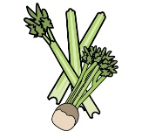 | 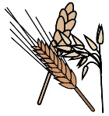 | 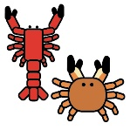 | 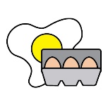 |  | 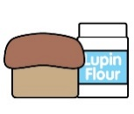 |  |  | 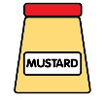 | 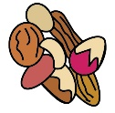 | 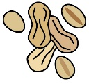 | 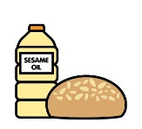
 | Celery | Cereals containing gluten | Crustaceans | Eggs | Fish | Lupin | Milk | Mollusc | Mustard | Nuts | Peanuts | Sesame seeds | Soya | Sulphur Dioxide
brioche bun |  | Y |  |  |  |  | Y
ciabatta |  | Y
baguette |  | Y
chunky chips
Dry-cured bacon |  |  |  |  |  |  |  |  |  |  |  |  |  | Y
Cumberland sausage and fried onions |  |  |  |  |  |  |  |  |  |  |  |  |  | Y
Slow-roasted pulled pork served with sage and onion stuffing and apple sauce |  | Y |  |  |  |  | Y
Roast beef with horseradish and roasted onions |  |  |  |  |  |  |  |  | Y
Turkey with stuffing and cranberry sauce |  | Y |  |  |  |  | Y
Leg of lamb with mint sauce |  |  |  |  |  |  |  |  |  |  |  |  |  | Y

Review date: | 30 September 2021 | Reviewed by: | Robert Stratton, Executive chef |  | You can find this template, including more information at www.food.gov.uk/allergy

