DISHES AND THEIR ALLERGEN CONTENT – Simply classic Allergens

DISHES | 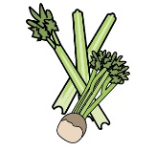 | 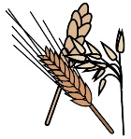 | 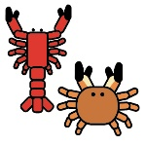 | 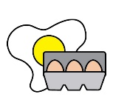 | 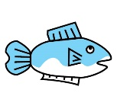 |  | 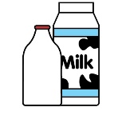 |  |  | 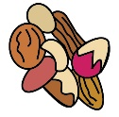 | 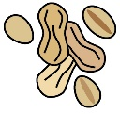 | 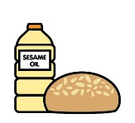
 | Celery | Cereals containing gluten | Crustaceans | Eggs | Fish | Lupin | Milk | Mollusc | Mustard | Nuts | Peanuts | Sesame seeds | Soya | Sulphur Dioxide
Traditional Roast Turkey with homemade stuffing and sausages wrapped in bacon finished with gravy | Y | Y |  | Y |  |  | Y |  |  |  |  |  |  | Y
Salmon fillet with crushed new potato cake flavoured with chives and spring onions on buttered mange tout with a white wine cream sauce | Y |  |  | Y | Y |  | Y |  | Y |  |  |  |  | Y
Wild mushroom, leek and roasted chestnut pudding served with buttered greens, a mustard sauce, crushed new potatoes and crispy sage. | Y | Y |  |  |  |  | Y |  | Y |  |  |  |  | Y
potatoes roasted in garlic and thyme, baton carrots and Brussel sprouts |  |  |  |  |  |  | Y
Traditional ‘Flamed’ Christmas pudding with rum sauce |  | Y |  | Y |  |  | Y |  |  | Y | Y |  |  | Y
Chocolate and orange cheesecake with a ginger base and caramel topping served with chocolate sticks |  | Y |  | Y |  |  | Y
Fresh fruit salad served with ice-cream |  |  |  | Y |  |  | Y

Review date: | 30 September 2021 | Reviewed by: | Robert Stratton, Executive chef |  | You can find this template, including more information at www.food.gov.uk/allergy

