DISHES AND THEIR ALLERGEN CONTENT – Christmas 3-course

DISHES | 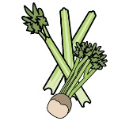 | 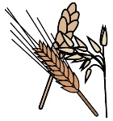 | 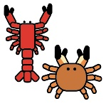 |  |  | 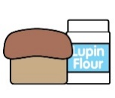 |  |  |  | 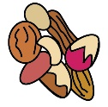
 | Celery | Cereals containing gluten | Crustaceans | Eggs | Fish | Lupin | Milk | Mollusc | Mustard | Nuts | Peanuts | Sesame seeds | Soya | Sulphur Dioxide
Homemade cream of winter Vegetable soup with crusty bread roll | Y | Y |  |  |  |  | Y
Pressed terrine of pork shoulder and ham hock topped with an apple and thyme jelly  served with dressed leaf, apple chutney, bread crisps and crackling stick |  | Y |  |  |  |  |  |  | Y |  |  |  |  | Y
Prawns wrapped in Scottish smoked salmon on a pea shoot salad with Marie rose sauce, cherry tomatoes and fresh cucumber |  |  | Y |  | Y |  | Y |  | Y |  |  |  |  | Y
Traditional Roast Turkey with homemade stuffing and sausages wrapped in bacon finished with gravy | Y | Y |  | Y |  |  | Y |  |  |  |  |  |  | Y
Salmon fillet with crushed new potato cake flavoured with chives and spring onions on buttered mange tout with a white wine cream sauce | Y |  |  | Y | Y |  | Y |  | Y |  |  |  |  | Y
Wild mushroom, leek and roasted chestnut pudding served with buttered greens, a mustard sauce, crushed new potatoes and crispy sage. | Y | Y |  |  |  |  | Y |  | Y |  |  |  |  | Y
potatoes roasted in garlic and thyme, baton carrots and Brussel sprouts |  |  |  |  |  |  | Y
Traditional ‘Flamed’ Christmas pudding with rum sauce |  | Y |  | Y |  |  | Y |  |  | Y | Y |  |  | Y
Winter Pavlova topped with mulled pears and fruits of the forest, fresh cream, homemade granola and a fruit coulis |  | Y |  | Y |  |  | Y |  |  |  |  |  |  | Y
Fresh fruit salad served with ice-cream |  |  |  | Y |  |  | Y

Review date: | 30 September 2021 | Reviewed by: | Robert Stratton, Executive chef |  | You can find this template, including more information at www.food.gov.uk/allergy

