DISHES AND THEIR ALLERGEN CONTENT – Hospitality pizzas Allergens

DISHES | 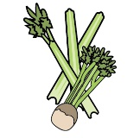 | 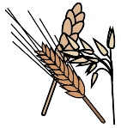 | 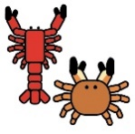 | 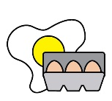 |  |  |  |  |  | 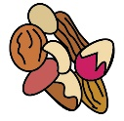 | 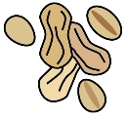 | 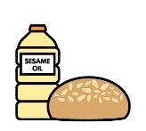
 | Celery | Cereals containing gluten | Crustaceans | Eggs | Fish | Lupin | Milk | Mollusc | Mustard | Nuts | Peanuts | Sesame seeds | Soya | Sulphur Dioxide
Pizzas
Margherita pizza |  | Y |  |  |  |  | Y
Pepperoni pizza |  | Y |  |  |  |  | Y |  |  |  |  |  |  | Y
Vegan jackfruit pizza |  | Y
Gluten free pizza |  |  |  |  |  |  | Y |  |  |  |  |  | Y
Salad pots
The Indian salad pot |  | Y |  |  |  |  |  |  |  |  |  |  | Y | Y
The Italian salad pot |  | Y |  | Y |  |  | Y |  |  |  |  |  |  | Y
The Middle Eastern salad pot |  | Y |  |  |  |  |  |  |  |  |  | Y | Y
The Asian Salad | Y |  |  |  |  |  |  |  | Y |  |  | Y | Y | Y
American Cobb salad |  | Y |  | Y |  |  | Y |  | Y |  |  |  |  | Y
Mediterranean salad |  |  |  |  |  |  | Y |  |  |  |  |  |  | Y

Review date: | 8th September 2021 | Reviewed by: | Robert Stratton, Executive chef |  | You can find this template, including more information at www.food.gov.uk/allergy

