DISHES AND THEIR ALLERGEN CONTENT – Pure indulgence Allergens

DISHES | 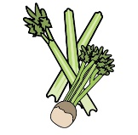 |  | 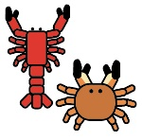 | 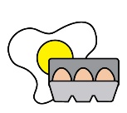 |  | 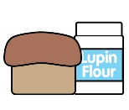 |  |  | 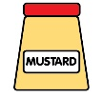 | 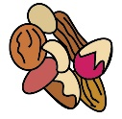 | 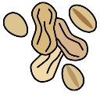 | 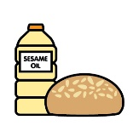
 | Celery | Cereals containing gluten | Crustaceans | Eggs | Fish | Lupin | Milk | Mollusc | Mustard | Nuts | Peanuts | Sesame seeds | Soya | Sulphur Dioxide
Starters
Pressed terrine of confit duck and foie gras wrapped in Bayonne ham and served on a micro herb salad and  raspberry vinaigrette | Y |  |  |  |  |  |  |  |  |  |  |  |  | Y
Pan-fried sea scallops served with crispy boudin noir, pea purée and fresh pea shoots | Y | Y | Y |  |  |  | Y | Y | Y |  |  |  |  | Y
Langoustine and Whitby cod bouillabaisse served with  a samphire aioli and homemade fennel bread | Y | Y | Y |  | Y |  | Y | Y |  |  |  |  |  | Y
Fillet of beef carpaccio served with home-pickled wild mushrooms, peppered rocket, parmesan shavings, Dijon emulsion and a crispy breaded poached hen’s egg |  | Y |  | Y |  |  | Y |  | Y |  |  |  |  | Y
Lowna goat’s cheese and wild garlic tortellini served with white truffle and English asparagus foam and sautéed girolles | Y | Y |  | Y |  |  | Y |  | Y |  |  |  |  | Y
Trio of smoked salmon. To include a smoked salmon, crab and prawn faggot on endive salad, smoked salmon tian topped with caviar on marinated cucumber and smoked salmon sushi roll with a light wasabi cream | Y | Y | Y | Y | Y |  | Y | Y | Y |  |  |  | Y | Y
Main course
All main courses are served with pomme fondant, turned carrots and buttered florets of broccoli and  green beans wrapped in pancetta. | Y |  |  |  |  |  | Y
Fillet steak crépinettes served with an oxtail crumble, baby carrots, wild mushrooms, asparagus, large  parmentiere potatoes and red wine jus | Y | Y |  |  |  |  | Y |  | Y |  |  |  |  | Y
Trio of Yorkshire pork, including spinach-stuffed fillet, confit shoulder cigarillo and belly bonbon served with wilted greens, turned carrot, apple crisps and sage café crème sauce | Y | Y |  | Y |  |  | Y |  | Y |  |  |  | Y | Y
Holme farm venison fillet on sticky red cabbage served with dauphinoise potatoes, young carrots, celeriac puree and buttered broad beans, finished with a juniper infused red wine jus

Fillet of line-caught sea bass on a julienne of soused vegetables with saffron potatoes, Black Sheep-battered lobster tail, a tomato and balsamic dressing with cracked black pepper and lemon crème fraiche  Breast of guineafowl filled with an asparagus mousse and served with the confit leg wrapped in spaghetti  potatoes, buttered baby vegetables, carrot purée and a sage jus | Y | Y | Y |  | Y |  | Y | Y |  |  |  |  |  | Y
Sweet onion and morel tart with buttered spinach, shallot and olive purée, braised pencil leeks and wild  garlic panna cotta | Y | Y |  | Y |  |  | Y |  | Y |  |  |  |  | Y
Desserts
Chocolate bread and butter pudding served with crème anglaise and marmalade ice cream |  | Y |  | Y |  |  | Y |  |  |  |  |  |  | Y
Raspberry and honey wafer tower with praline cream, red berry coulis and caramel hazelnut |  | Y |  | Y |  |  | Y
Strawberry brioche tian served with lemon sorbet, chantilly cream and toasted almonds |  | Y |  | Y |  |  | Y |  |  | Y
Pear and frangipane tart with a Granny Smith mousse, tuile biscuit and vanilla cream |  | Y |  | Y |  |  | Y |  |  | Y
Trio of crème brûlée including raspberry, dark chocolate and tonka bean, finished with seasonal berries and all-butter shortbread bites |  | Y |  | Y |  |  | Y
Selection of Yorkshire cheeses and homemade chutneys served with fresh walnut bread, celery sticks and grapes | Y | Y |  |  |  |  | Y

Review date: |  | Reviewed by: |  | 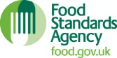 | You can find this template, including more information at www.food.gov.uk/allergy

