DISHES AND THEIR ALLERGEN CONTENT – Simply classic Allergens v2

DISHES | 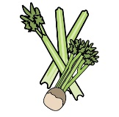 | 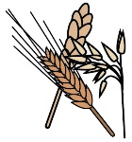 | 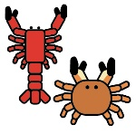 | 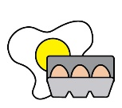 |  | 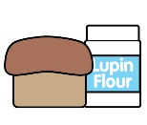 |  |  |  | 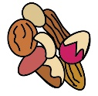 | 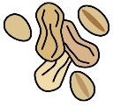 | 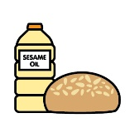
 | Celery | Cereals containing gluten | Crustaceans | Eggs | Fish | Lupin | Milk | Mollusc | Mustard | Nuts | Peanuts | Sesame seeds | Soya | Sulphur Dioxide
Homemade soup with freshly baked bread | Y | Y |  |  |  |  | Y
Chicken liver paté, homemade chutney, picked leaves, toast |  | Y |  |  |  |  | Y |  |  |  |  |  |  | Y
Prawns, salad leaves, Marie Rose sauce, buttered brown bread, fresh lemon |  | Y | Y | Y |  |  | Y
Bacon and Wensleydale tartlet, picked leaves, balsamic reduction |  | Y |  | Y |  |  | Y
Fan of honeydew melon, kiwi, strawberry, passion fruit coulis
Roasted topside of local beef, crisp Yorkshire pudding, red wine sauce, horseradish sauce | Y | Y |  | Y |  |  | Y |  |  |  |  |  |  | Y
Chicken breast in bacon, stuffing, roasted onions and mushrooms, traditional gravy | Y | Y |  |  |  |  | Y |  |  |  |  |  |  | Y
Roast pork loin, crackling, pork gravy, apple sauce | Y |  |  |  |  |  |  |  |  |  |  |  |  | Y
Breast of turkey, homemade stuffing, sausage wrapped in bacon, traditional gravy | Y | Y |  | Y |  |  | Y |  |  |  |  |  |  | Y
Salmon fillet, herb crust, lemon and chive cream sauce |  | Y |  |  | Y |  | Y |  |  |  |  |  |  | Y
Tian of charred Mediterranean vegetables with goat’s cheese beignets and tomato and basil sauce | Y | Y |  | Y |  |  | Y
Traditional cheesecake, berries, fruit coulis |  | Y |  | Y |  |  | Y
Profiteroles, warm chocolate sauce |  | Y |  | Y |  |  | Y
Fresh fruit salad, vanilla ice cream |  |  |  | Y |  |  | Y
Chocolate torte, whipped vanilla cream |  | Y |  |  |  |  | Y
Treacle sponge, custard |  | Y |  | Y |  |  | Y

Review date: | 8th Sep 2021 | Reviewed by: | Robert Stratton, Executive Chef |  | You can find this template, including more information at www.food.gov.uk/allergy

