DISHES AND THEIR ALLERGEN CONTENT – Sandwiches

DISHES | 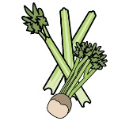 | 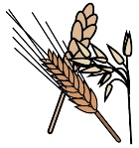 | 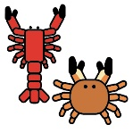 | 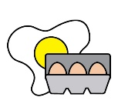 |  |  | 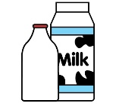 |  | 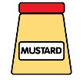 | 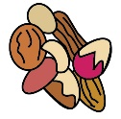 | 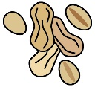 | 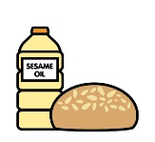
 | Celery | Cereals containing gluten | Crustaceans | Eggs | Fish | Lupin | Milk | Mollusc | Mustard | Nuts | Peanuts | Sesame seeds | Soya | Sulphur Dioxide
Chicken and bacon with cress |  | Y |  | Y |  |  |  |  | Y
Ham and tomato |  | Y
Tuna mayo and cucumber |  | Y |  |  | Y |  |  |  | Y
Egg mayo and cress |  | Y |  | Y |  |  |  |  | Y
Cheese and spring onion |  | Y |  | Y |  |  | Y |  | Y
Cottage cheese salad |  | Y |  |  |  |  | Y
Chicken tikka (halal) |  | Y |  | Y |  |  | Y |  | Y
Coronation chicken (halal) | Y | Y |  | Y |  |  |  |  | Y |  |  |  |  | Y
Cheese and pickle |  | Y |  |  |  |  | Y |  |  |  |  |  |  | Y
Beef and horseradish |  | Y |  | Y |  |  |  |  | Y
Cheese and tomato |  | Y |  |  |  |  | Y

Review date: | 5th November 2021 | Reviewed by: | Robert Stratton |  | You can find this template, including more information at www.food.gov.uk/allergy

