DISHES AND THEIR ALLERGEN CONTENT – 2022 hospitality allergens

DISHES | 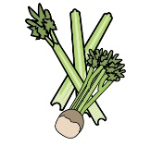 | 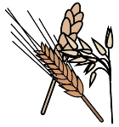 | 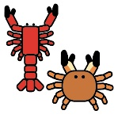 | 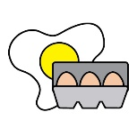 |  | 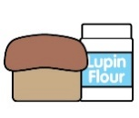 |  |  |  | 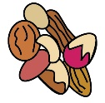 | 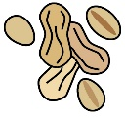 | 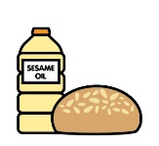
 | Celery | Cereals containing gluten | Crustaceans | Eggs | Fish | Lupin | Milk | Mollusc | Mustard | Nuts | Peanuts | Sesame seeds | Soya | Sulphur Dioxide
Sausage Roll |  | y |  |  |  |  | y |  |  |  |  |  |  | y
Homemade Ham and Cheddar Cheese Quiche |  | y |  | y |  |  | y
Pork Pie and Pickle |  | y |  |  |  |  |  |  |  |  |  |  |  | y
Chicken Yakatori |  | y |  |  |  |  |  |  |  |  |  |  | y
Filo King Prawns |  | y | y |  |  |  |  |  |  |  |  |  | y
Chicken Pieces |  | y
Vegetable Crisps
Mini Spring Rolls |  | y |  |  |  |  |  |  |  |  |  |  | y
Vegetable Samosa |  | y |  |  |  |  |  |  |  |  |  |  | y
Pizza Slice |  | y |  |  |  |  | y
Onion Bhaji |  | y
Homemade Vegetable Quiche |  | y |  | y |  |  | y
Cheese and Leek Roll |  | y |  | y |  |  | y |  | y
Spinach and Feta Goujons |  | y |  |  |  |  | y
Vegetable Pakora | y | y |  |  |  |  |  |  | y |  |  | y | y
Crudities and Dips | y |  |  |  |  |  |  |  |  |  |  | y
Spring onion and chive, new potato salad |  |  |  |  |  |  | y |  | y
Cous cous salad |  | y
Pesto pasta salad |  | y |  |  |  |  | y
Marinated tomato, mozzarella, olive and basil salad |  |  |  |  |  |  | y
Dessert selection
Chocolate Brownie |  | y |  | y |  |  | y
Carrot Cake |  | y |  | y |  |  | y |  |  | y |  |  |  | y
Mini Cream Cakes |  | y |  | y |  |  | y |  |  |  |  |  |  | y
Mini Fruit Tartlets |  | y |  | y |  |  | y |  |  |  |  |  |  | y
Scone
Mini Homemade Flapjack |  | y |  |  |  |  | y
Fruit Platter
Breakfast selection
Plain Croissant |  | y |  | y |  |  | y
Pain au Chocolat |  | y |  | y |  |  | y
Cinnamon Swirl |  | y |  | y |  |  | y
Almond Croissant |  | y |  | y |  |  | y |  |  | y

Review date: | 26 January 2022 | Reviewed by: | Robert Stratton |  | You can find this template, including more information at www.food.gov.uk/allergy

